School Development Plan

Name of school: _______________________

Approval from: ________________________

Approval date: ______.______.___________

Data of next revision: ______.______.___________

BASIC EMIS DATA
Municipality |  |  |  |  |  | -----------------------------
 | Name and adress of school  _______________________ |  |  | contact person | tel. | fax | email | location | Urban |  | teaching language in school | Albanian  Serbian  Turkish  Bosnian
 |  |  |  |  |  |  |  | location | Rural |  | teaching language in school
SCHOOL BUILDING AND PHYSICAL CONDITION | Nr. of classrooms |  |  | Total classes m2 |  |  | Nr. of special educ. classes |  |  |  | special classes m2
SCHOOL BUILDING AND PHYSICAL CONDITION | Laboratores | Yes(howmuc |  | Cabinets | Yes(howmuc |  | Workroom |  | Yes |  | Teachers room |  | Yes
SCHOOL BUILDING AND PHYSICAL CONDITION | Laboratores | No |  | Cabinets | No |  |  |  | No |  |  |  | No
SCHOOL BUILDING AND PHYSICAL CONDITION | Men's toilete | Yes |  | Female toilette | Yes |  | Toiolete for pupils with special needs |  | Yes |  | Teachers toilets |  | Yes
SCHOOL BUILDING AND PHYSICAL CONDITION | Men's toilete | No |  | Female toilette | No |  |  |  | No |  |  |  | No
SCHOOL BUILDING AND PHYSICAL CONDITION | Library | Yes |  | Kitchen | Yes |  | Gymnastics Room |  | Yes |  | Depo |  | Yes
SCHOOL BUILDING AND PHYSICAL CONDITION | Library | No |  | Kitchen | No |  |  |  | No |  |  |  | No
SCHOOL BUILDING AND PHYSICAL CONDITION | preprimary class | Yes |  | Connection to water supply | Yes |  | Connection to sewage network |  | Yes |  | Heating method |  | Clasic
SCHOOL BUILDING AND PHYSICAL CONDITION | preprimary class | No |  | Connection to water supply | No |  |  |  | No |  |  |  | Central
 |  |  |  |  |  |  |  |  |  |  |  |  | Other
SCHOOL BUILDING AND PHYSICAL CONDITION | Fences | Yes |  | Sports field | Yes |  | Other:  ____________ (specify) |  | Yes |  | Other: ____________ (specifiy |  | Yes
SCHOOL BUILDING AND PHYSICAL CONDITION | Fences | No |  | Sports field | No |  |  |  | No |  |  |  | No
SCHOOL BUILDING AND PHYSICAL CONDITION | Shifts | 1 |  | School buildings | 1 |  | Class | Preschool |  |  | Paralells nr.
SCHOOL BUILDING AND PHYSICAL CONDITION | Shifts | 2 |  | School buildings | 2 |  | Class | Class 1 - 9
SCHOOL BUILDING AND PHYSICAL CONDITION | Shifts | 3 |  | School buildings | 3 |  | Class | Combined classes
SCHOOL BUILDING AND PHYSICAL CONDITION | Shifts | 4 |  | School buildings | 4 |  | Class | Attached classes
Ansvwers Yes make with ……..X; Ansvwers No make with ………0
_____________________________________________________________________________________________________________________________
STUDENTS | Class |  |  |  |  |  | Travel distance |  |  |  |  |  |  |  |  |  |  | How many students traveling
 |  |  |  |  |  |  |  |  |  |  |  |  |  |  |  |  |  | Deri 1km |  |  |  |  | 1-2km |  |  |  |  |  | 2-3km |  |  |  |  |  | 3-4km |  |  |  |  |  | 4-5km |  |  |  |  |  | 5+ km
STUDENTS | Parallel
STUDENTS | Numri I nxënësve |  |  |  |  |  | Mashkull |  |  |  |  |  |  |  |  |  |  |  |  |  |  |  | Femëra
STUDENTS | Etnicity |  |  | Albanian |  |  | Serbian |  |  |  | Turk |  |  |  | Bosnian |  |  | Goran |  |  |  |  | Ashkali |  |  |  |  |  | Roma |  |  |  |  |  | Egyptian |  |  |  |  |  | Croatian |  |  |  |  |  | Others
STUDENTS | Students with special needs |  |  | intelektual |  |  |  |  |  |  | Hear  Injuries |  |  |  |  |  |  | Hearing Damage |  |  |  |  |  |  |  |  |  |  | Physical Damage |  |  |  |  |  |  |  |  |  |  |  | Multiple  Damage
STUDENTS | Movement of students (gender, ethnicity) |  |  | Gender |  |  | M |  |  |  | F |  |  |  | Students who goes  (+ ethnicity) |  | Gender |  |  |  |  |  |  |  |  |  | M |  |  |  | F |  |  |  | Drop – out students  (+ ethnicity) |  |  |  | Gender |  |  |  | M |  |  |  |  |  |  | F
STUDENTS |  |  |  | Albanian |  |  |  |  |  |  |  |  |  |  |  |  | Albanian |  |  |  |  |  |  |  |  |  |  |  |  |  |  |  |  |  |  |  |  |  | Albanian
STUDENTS |  |  |  | Serb |  |  |  |  |  |  |  |  |  |  |  |  | Serb |  |  |  |  |  |  |  |  |  |  |  |  |  |  |  |  |  |  |  |  |  | Serb
STUDENTS |  |  |  | RAE |  |  |  |  |  |  |  |  |  |  |  |  | RAE |  |  |  |  |  |  |  |  |  |  |  |  |  |  |  |  |  |  |  |  |  | RAE
STUDENTS |  |  |  | Other |  |  |  |  |  |  |  |  |  |  |  |  | Other |  |  |  |  |  |  |  |  |  |  |  |  |  |  |  |  |  |  |  |  |  | Other
STUDENTS | Students from families  with social assistance |  |  |  |  |  | All |  |  |  |  |  |  |  | Male |  |  |  |  |  |  |  |  |  |  |  |  |  |  |  |  |  |  |  | Female
TEACHING | Lessons planning |  |  |  |  |  | Total planned teaching hours for last year |  |  |  |  |  |  |  |  | Total planned teaching hours for current year |  |  |  |  |  |  |  |  |  |  |  |  |  |  |  |  | the held lessons |  |  |  |  | Previous year |  |  |  |  |  |  | Current year
TEACHING | Success |  | subject |  |  |  |  | Students Passing |  |  |  |  |  |  |  |  |  |  | Students Repeuter |  |  |  |  |  |  |  |  |  |  |  |  |  |  |  |  |  | Students without marks
TEACHING |  |  |  |  |  |  |  | Male |  |  |  | Female |  |  |  |  |  |  | Male |  |  |  |  |  |  |  |  | Male |  |  |  |  |  |  |  |  | Female |  |  |  |  |  |  | Male
TEACHING |  |  | Albanian Language
TEACHING |  |  | Mathematic
TEACHING |  |  | Biology
TEACHING |  |  | Phizics
TEACHING |  |  | Chemistry
TEACHING |  |  | English language
TEACHERS |  | Name of the Teacher |  |  |  | Gender |  |  |  |  |  |  | Ethnicity |  |  |  |  |  |  |  |  |  |  |  | Qualified |  |  |  |  |  |  |  |  |  |  |  |  |  |  | Working hours
 |  | Please attach salary list |  |  |  | Male |  |  | Female |  |  |  |  |  |  |  |  |  |  | M |  | F |  |  | Male |  |  |  |  |  |  |  |  | Female |  |  |  |  |  | How much teaching hours have female |  |  |  |  |  | How much teaching hours have male
 |  |  |  |  |  |  |  |  |  |  |  |  | Albanian
 |  |  |  |  |  |  |  |  |  |  |  |  | Serb
 |  | Total |  |  |  |  |  |  |  |  |  |  | Bosnian
 |  |  |  |  |  |  |  |  |  |  |  |  | RAE
 |  |  |  |  |  |  |  |  |  |  |  |  | Other
ADMINISTRATIVE STAFF |  | Names – Nr of staff |  |  |  | Gender |  |  |  |  |  |  |  | Etnicity |  |  |  |  |  |  |  |  |  | Duty of work
 |  | Please attach salary list |  |  |  | Male |  |  |  | Male |  |  |  |  |  |  |  |  |  | M | F |  |  |  |  | Director |  |  |  |  |  | Deputy Director |  |  |  | Administrative staff |  |  |  |  |  | Librarian |  |  |  |  |  |  | Other
 |  |  |  |  |  |  |  |  |  |  |  |  |  | Albanian
 |  |  |  |  |  |  |  |  |  |  |  |  |  | Serb
 |  | Total |  |  |  |  |  |  |  |  |  |  |  | Bosnian
 |  |  |  |  |  |  |  |  |  |  |  |  |  | RAE
 |  |  |  |  |  |  |  |  |  |  |  |  |  | Other

SUPPORT STAFI | Names – Nr of staff |  | Gender |  | Etnicity |  |  | Duty of work
SUPPORT STAFI | Please attach salary list |  | Male | Male |  | M | F |  | Security | Maintenace | Cleanning | Other
 |  |  |  |  | Albanian
 |  |  |  |  | Serb
SUPPORT STAFI | Total |  |  |  | Bosnian
 |  |  |  |  | RAE
 |  |  |  |  | Other

VISION
In ten years our school will be……..…………………………..…………………………..…………………………..……………………………..
I. Outcomes and success of the school
1. 80% of the pupils in our school achieve …….......…………..…………………………..………………………………..…………………
2. ..……………………………………………………………………… ..………………………… ..……………………………………………………………
II. Culture of Learning-Quality of Teaching and Learning Process
1. Learning and Teaching Methods……………………………………..…………………………..…………………….………....…….………
2. ……………………………………………………………………………………..…………………………..…………………………….………….….……
III. School Culture
1. The atmosphere in the school…………………………………..…………………………..……………………..………………………………
2. ………………… …………………………………………………………………………..…………………………..………………………………..………
IV. School Executive and School Management
1. The school council………………………....………..…………………………..…………………………..………………………….……..………
2. ………………………………………………………………………………………...…………………………..………………………….………………….
V. Professionalism of Teachers and Personnel Development
1. ………………..…………………………………………………………………..………..…………………………..…………..…...………………………
VI. Targets and Strategies of Quality Development
1. ……………..…………………………………………………………………..……………………..…………………………..………………………….…
VII. Inclusion ………..……………………………………………………………………..……………………………………..…………………………..
- …………………………..…………………………………………………………………..…..…………………………..…………………………………
VIII. Facility Management
- ……………………......................................................................................…………………………..…………………………..
- .................................................................................................................. ..………………………………….............

DEVELOPMENT PHASES OF THE SCHOOL DEVELOPMENT PLAN
Project Iniciation for darfting SDP

Evaluation of SDP

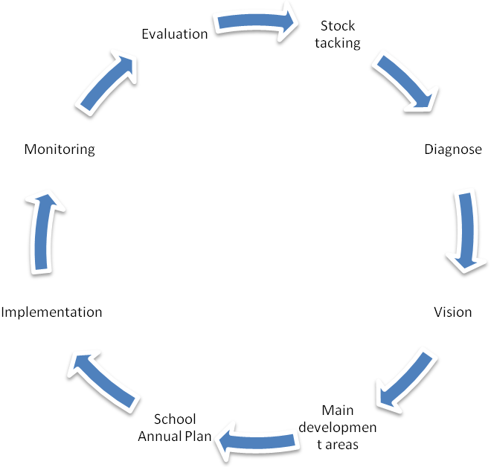

SDP Planning
SDP Implementation

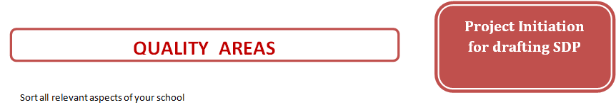
I  Outcomes and  Successes of the  School | II  Culture of Learning-  Quality of Teaching and  Learning Processes | III  School Culture | IV  School Executive and  School Management | V  Professionalism of  Teachers and Personnel  Development | VI  Targets and  Strategies of Quality  Development | VII  Inclusion | VIII  Facility Management
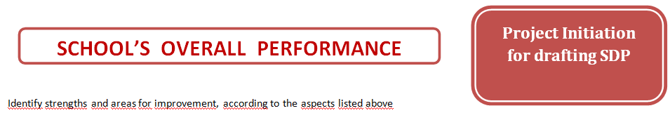
 |  | I  Outcomes and  Successes of the  School | II  Culture of Learning-  Quality of Teaching and  Learning Processes | III  School Culture | IV  School Executive and  School Management | V  Professionalism of  Teachers and Personnel  Development | VI  Targets and  Strategies of Quality  Development | VII  Inclusion | VIII  Facility Management
Advantages | Strengths
Problems | Areas for improovement
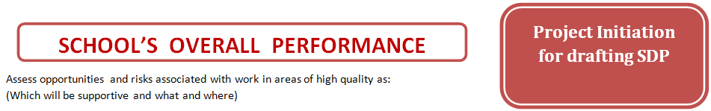
 | I  Outcomes and  Successes of the  School | II  Culture of Learning-  Quality of Teaching and  Learning Processes | III  School Culture | IV  School Executive and  School Management | V  Professionalism of  Teachers and Personnel  Development | VI  Targets and  Strategies of Quality  Development | VII  Inclusion | VIII  Facility Management
Oportunities
Risks

Priorities for coming years:
1.
2.
3.
4.
5.


Prioritetet | Quality Areas | Particular aspects of quality fields  For three-year period | Timescale
Prioritetet | Quality Areas | Particular aspects of quality fields  For three-year period | 2012 |  |  |  | 2013 |  |  |  | 2014
Prioritetet | Quality Areas | Particular aspects of quality fields  For three-year period | I-VI |  | VII-XII |  | I-VI |  | VII-XII |  | I-VI |  | VII-XII
1.
2.
3.
4.

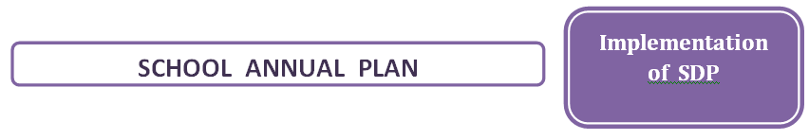
Priority nr ____:..............................................................................................................................................................................................................

Milestone | Aktivities - tasks | Responsibility | Costs | Recourses | Timescale


Until 15 September 201__
Areas | Milestone | Progress |  |  | Obstacle | Achievements | Perspective / Reactions
Areas | Milestone | A | B | C | Obstacle | Achievements | Perspective / Reactions
Legend: A = Completed in time √
B = There are delays during implementation√
C = Cancelled or in dangerous to be cancelled √

